**VISHWESHWARAYA TECHNOLOGICAL UNIVERSITY**

**BELGAUM – 590014**



# R Mini project on

**Company Financial Analysis in R Programming**

*A mini project report submitted in partial fulfilment of the requirements for the IV Semester degree of* ***Bachelor of Engineering in Computer Science and Technology*** *of Visvesvaraya Technological University, Belgaum.*

**Submittted by**

Shabaz Pasha 1DT21CS137

Somashekhar H A 1DT21CS154

Renukaprasad K R 1DT22CS414

Vikram S 1DT22CS416

# Under the Guidance of

# Shilpa M

Assistant Professor

Computer Science and Engineering

Dayananda Sagar Academy of Technology & Management



**Department of Computer Science and Engineering**

**DAYANANDA SAGAR ACADEMY OF TECHNOLOGY AND**

**MANAGEMENT**

Udayapura, Kanakapura Road, Bangalore-560082 ,2022-2023

**CONTENT**

|  |  |  |
| --- | --- | --- |
| **SL.NO** | **PARTICULARS** | **PAGE NO** |
| 1. | Abstract | 1 |
| 2. | Introduction | 2-5 |
| 3. | Code | 6-10 |
| 4. | Design &Flowchart | 11 |
| 5. | Output Screenshots | 12-16 |
| 6. | Conclusion | 17 |
| 7. | References | 18 |

**ABSTRACT**

This project aims to conduct a comprehensive financial analysis of [Company Name], a prominent player in [industry]. By employing a diverse range of financial tools and methodologies, we will assess the company's financial health, performance, and overall stability. Key areas of focus will include profitability, liquidity, solvency, efficiency, and market valuation. The results of this analysis will provide valuable insights for stakeholders, investors, and decision-makers, enabling them to make informed strategic choices and investments in [Company Name]. Through rigorous examination of financial statements, ratios, and industry benchmarks, this project seeks to offer a detailed perspective on the financial standing of [Company Name], facilitating better-informed business decisions in a dynamic market environment.

**INTRODUCTION**

Financial analysis is a vital component of assessing the health and performance of any organization. In an era marked by economic uncertainties and rapidly evolving market dynamics, a comprehensive understanding of a company's financial standing is indispensable for informed decision-making. This report delves into the financial landscape of [Company Name], aiming to provide a detailed analysis of its financial performance, strengths, weaknesses, and prospects.

Through an examination of key financial statements, ratios, and other relevant data, this analysis seeks to answer critical questions about [Company Name]'s fiscal stability and growth potential. In doing so, it equips stakeholders, investors, and management with the necessary insights to make sound financial decisions**.** The report is structured to cover various aspects of [Company Name]'s financial performance, including liquidity, profitability, solvency, and efficiency. It will also explore market trends, industry benchmarks, and potential risks that may impact the company's future financial outlook.

**Revenue, gross profit, and operating expenses are key financial metrics that provide insights into a company's financial performance.**

1. \***Revenue**\*:

- *Definition*: Revenue, also known as sales or turnover, is the total amount of money a company earns from its primary operations, such as selling products or providing services, during a specific period, typically a fiscal quarter or year.

- *Importance*: Revenue is a fundamental indicator of a company's ability to generate income from its core business activities. It's a key driver of a company's growth and profitability.



2. \***Gross Profit**\*:

- *Definition*: Gross profit represents the amount of money left over after deducting the direct costs of producing or delivering the goods or services sold. It is calculated as:

**Gross Profit = Revenue - Cost of Goods Sold (COGS)**

- *Importance*: Gross profit measures a company's operational efficiency and profitability before accounting for other operating expenses. It indicates how well a company manages its production or service delivery costs.

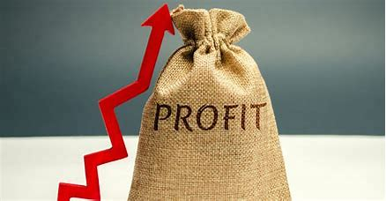

3. \***Operating Expenses**\*:

- *Definition*: Operating expenses, also known as OPEX, are the costs incurred by a company in its day-to-day business operations, excluding the cost of goods sold. These expenses include items such as salaries, rent, utilities, marketing, and administrative costs.

- *Importance*: Operating expenses reflect the ongoing costs of running a business. Monitoring and managing these expenses is crucial for maintaining profitability. The difference between gross profit and operating expenses is often referred to as "operating income" or "operating profit."

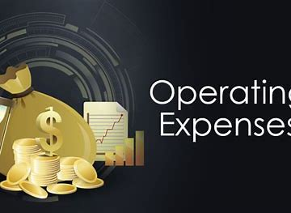

**Assets and liabilities are essential components of a company's balance sheet, which provides a snapshot of its financial position at a specific point in time. Let's delve into the details of assets and liabilities:**

\***Assets**\*:

1. *Current Assets*:

- *Definition*: Current assets are assets that are expected to be converted into cash or used up within one year or one operating cycle, whichever is longer. They are typically more liquid and include items like cash, accounts receivable, inventory, and short-term investments.

- *Importance*: Current assets represent a company's short-term liquidity and its ability to meet immediate financial obligations.

2. \*\***Non-Current Assets (Fixed Assets)**\*\*:

- *Definition*: Non-current assets are long-term assets that are not expected to be converted into cash within one year. These include property, plant, equipment, intangible assets (like patents or trademarks), and long-term investments.

- *Importance*: Non-current assets reflect a company's investments in its long-term growth and operations.

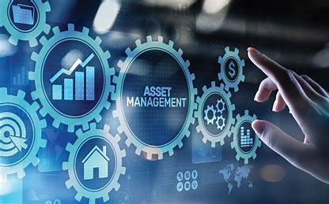

\***Liabilities**\*:

1. *Current Liabilities*:

- *Definition*: Current liabilities are obligations that are expected to be settled within one year or one operating cycle, whichever is longer. Common examples include accounts payable, short-term loans, and accrued expenses.

- *Importance*: Current liabilities represent a company's short-term obligations and its need for liquidity to meet these obligations.

2. **Non-Current Liabilities (Long-Term Liabilities)**:

- *Definition*: Non-current liabilities are long-term obligations that are not due for settlement within one year. Examples include long-term loans, bonds, and deferred tax liabilities.

- *Importance*: Non-current liabilities reflect a company's long-term financial commitments and its ability to manage its long-term debt.



\*\***Net Assets (Equity)**\*\*:

- *Definition*: Net assets, also known as shareholders' equity or owner's equity, represent the residual interest in the assets of the entity after deducting liabilities. It's calculated as Assets - Liabilities.

- *Importance*: Net assets reflect the ownership interest in a company and provide insights into its overall financial health. It represents the value left for shareholders if all liabilities were paid off.

**Code:-**

x<-read.csv("C:/Users/Renukaprasad K R/OneDrive/Documents/Renukaprasad/financials of a company.csv")

# Financial data (in millions)

revenue <-x$revenue

cost_of_goods_sold <- x$cost_of_goods_sold

operating_expenses <-x$operating_expenses

cash <- x$cash

accounts_receivable <-x$accounts_receivable

inventory <- x$inventory

short_term_debt <- x$short_term_debt

accounts_payable <- x$accounts_payable

long_term_debt <- x$long_term_debt

# Calculate additional financial metrics

gross_profit <- revenue - cost_of_goods_sold

net_income <- gross_profit - operating_expenses

total_current_assets <- cash + accounts_receivable + inventory

total_current_liabilities <- short_term_debt + accounts_payable

total_assets <- x$total_assets

total_liabilities <- total_current_liabilities + long_term_debt

equity <- total_assets - total_liabilities

operating_cash_flow <- x$operating_cash_flow

capital_expenditure <- x$capital_expenditure

free_cash_flow <- operating_cash_flow - capital_expenditure

gross_margin <- (gross_profit / revenue) * 100

return_on_equity <- (net_income / equity) *100

# Plot 1: Revenue, Gross Profit, and Operating Expenses

plot(c(2020,2021,2022,2023,2024), revenue, type = "b", col = "blue", pch = 16, ylim = c(0, 350),

xlab = "Year", ylab = "Amount (in millions)", main = "Revenue, Gross Profit, and Operating Expenses")

lines(c(2020,2021,2022,2023,2024), gross_profit, type = "b", col = "green", pch = 17)

lines(c(2020,2021,2022,2023,2024), operating_expenses, type = "b", col = "red", pch = 18)

legend("topleft", legend = c("Revenue", "Gross Profit", "Operating Expenses"),

col = c("blue", "green", "red"), pch = c(16, 17, 18), bty = "o",cex = .7)

Lables <-c("revenue", "gross_profit", "operating_expenses")

info <-c(length(revenue), length(gross_profit), length(operating_expenses))

pie(info ,labels = Lables,col = c("blue", "green","red"),main = "Pie Chart for Revenue, Gross Profit, and Operating Expenses",cex =1.2,radius = .8,border = "black")

legend("bottomleft", legend = c("Revenue", "Gross Profit", "Operating Expenses"),

col = c("blue", "green", "red"), pch = c(16, 17, 18), bty = "o",cex = .7)

# Plot 2: Net Income

plot(c(2020,2021,2022,2023,2024), net_income, type = "b", col = "purple", pch = 15,

xlab = "Year", ylab = "Net Income (in millions)", main = "Net Income")

legend("topleft", legend = c("Net Income"), col = c("blue"), pch = c(16), bty = "o",cex = .7)

barplot(net_income,names.arg = c(2020,2021,2022,2023,2024), col = "blue", main="Net Income(#Bar Graph)" , xlab = "year",ylab = "Net Income (in millions)")

hist(net_income,ylab = "Frequency", xlab = "Net Income (in millions)",col = "purple",main="Net Income(in millions)(#HISTOGRAM)")

# Plot 3: Total Current Assets and Total Current Liabilities

plot(c(2020,2021,2022,2023,2024), total_current_assets, type = "b", col = "orange", pch = 16, ylim = c(20, 160),

xlab = "Year", ylab = "Amount (in millions)", main = "Total Current Assets and Total Current Liabilities")

lines(c(2020,2021,2022,2023,2024), total_current_liabilities, type = "b", col = "brown", pch = 17)

legend("topleft", legend = c("Total Current Assets", "Total Current Liabilities"),

col = c("orange", "brown"), pch = c(16, 17), bty = "o",cex = .7)

barplot(total_current_assets, names.arg = c(2020,2021,2022,2023,2024), col = "orange", main="Total Current Assets" , xlab = "year",ylab = "Assets Hold")

barplot(total_current_liabilities, names.arg = c(2020,2021,2022,2023,2024), col = "brown", main="Total Current Liabilities" , xlab = "year",ylab = "liabilites")

# Plot 4: Free Cash Flow and Operating Cash Flow

plot(c(2020,2021,2022,2023,2024), free_cash_flow, type = "b", col = "cyan", pch = 16, ylim = c(60, 140),

xlab = "Year", ylab = "Amount (in millions)", main = "Free Cash Flow and Operating Cash Flow")

lines(c(2020,2021,2022,2023,2024), operating_cash_flow, type = "b", col = "green", pch = 17)

legend("topleft", legend = c("Free Cash Flow", "Operating Cash Flow"),

col = c("cyan", "green"), pch = c(16, 17), bty = "o",cex = .7)

hist(free_cash_flow ,ylab = "Frequency", xlab = "Net Income (in millions)",col = "cyan",main="Free Cash Flow,(#HISTOGRAM)")

hist(operating_cash_flow ,ylab = "Frequency", xlab = "Net Income (in millions)",col = "green",main="Free Cash Flow,(#HISTOGRAM)")

# Plot 5: Gross Margin and Return on Equity

plot(c(2020,2021,2022,2023,2024), gross_margin, type = "b", col = "purple", pch = 15, ylim = c(0,50),

xlab = "Year", ylab = "Percentage", main = "Gross Margin and Return on Equity")

lines(c(2020,2021,2022,2023,2024), return_on_equity, type = "b", col = "orange", pch = 16)

legend("topright", legend = c("Gross Margin", "Return on Equity"),

col = c("purple", "orange"), pch = c(15, 16), bty = "o",cex = .6)

barplot(gross_margin, names.arg = c(2020,2021,2022,2023,2024), col = "purple", main="Gross Margin" , xlab = "year",ylab = "Gross Margin")

#plot 6: assets and liabilities

lables <-c("Total_Current_Assets", "Total_Current_Liabilities", "Total_Assets", "Total_Liabilities")

data <-c(sum(total_current_assets), sum(total_current_liabilities), sum(total_assets), sum(total_liabilities))

pie(data,labels = lables,col = c("red", "green","yellow","blue"),main = "Assets and Liabilities",cex =1,radius = .6)

legend("bottomleft", legend = c("Total_Current_Assets", "Total_Current_Liabilities","Total_Assets", "Total_Liabilities"),

col = c("red","green","yellow", "blue"), pch = c(15, 16), bty = "o",cex = .7)

**#creating a data frame**

pasha = data.frame(

revenue = c(200, 230, 250, 270, 300),

cost_of_goods_sold = c(120, 130, 150, 160, 180),

operating_expenses = c(70, 75, 80, 85, 90),

cash = c(30, 35, 50, 55, 60),

accounts_receivable = c(25, 28, 30, 35, 40),

inventory = c(35, 38, 40, 45, 50),

short_term_debt = c(15, 18, 20, 25, 30),

accounts_payable = c(20, 22, 30, 35, 40),

long_term_debt = c(80, 90, 100, 110, 120),

total_assets = 400,

operating_cash_flow = c(90, 95, 100, 110, 120),

capital_expenditure = c(25, 28, 30, 35, 40),

stringsAsFactors = FALSE

)

write.csv(pasha,"C:/Users/Renukaprasad K R/OneDrive/Documents/Renukaprasad/financials of a company.csv", row.names=TRUE)

x<-read.csv("C:/Users/Renukaprasad K R/OneDrive/Documents/Renukaprasad/financials of a company.csv")

print(x)

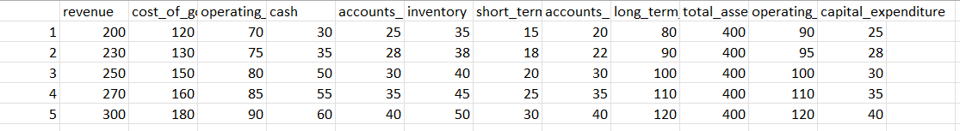 **Financials of company**

**Flow Chart**

START

PROCESS BLOCK

PROCESS BLOCK

PROCESS BLOCK

FREE CASH FLOW , OPERATING CASH FLOW

GROSS MARGIN, RETURN ON EQUITY

NET INCOME

PROCESS BLOCK

PROCESS BLOCK

TOTAL CURRENT ASSETS, TOTAL CURRENT LIABILITIES

PROCESS BLOCK

Plot of Revenue, Gross profit and operating expenses

ASSETS, LIABILITIES

END

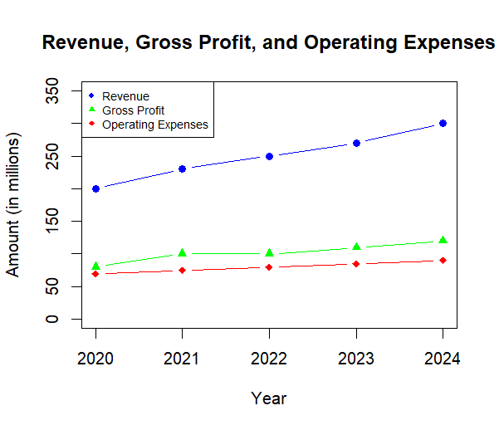 **Output**

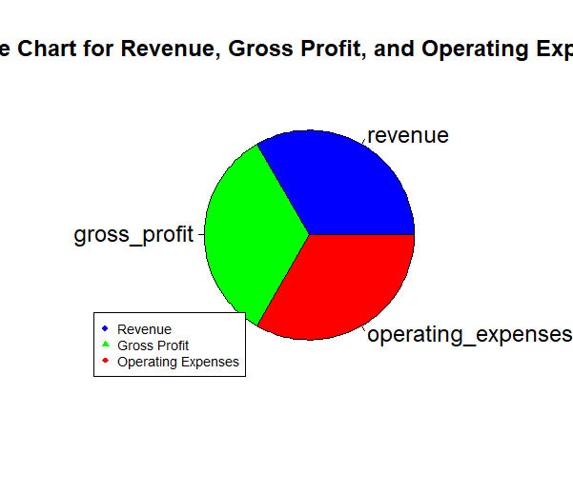

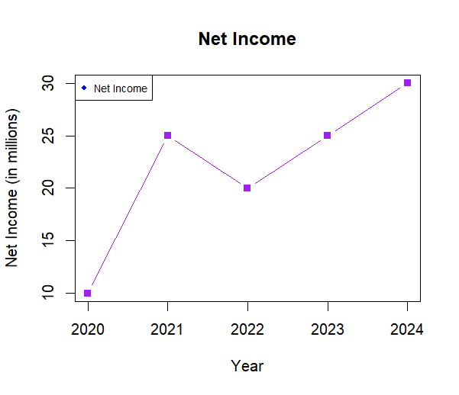

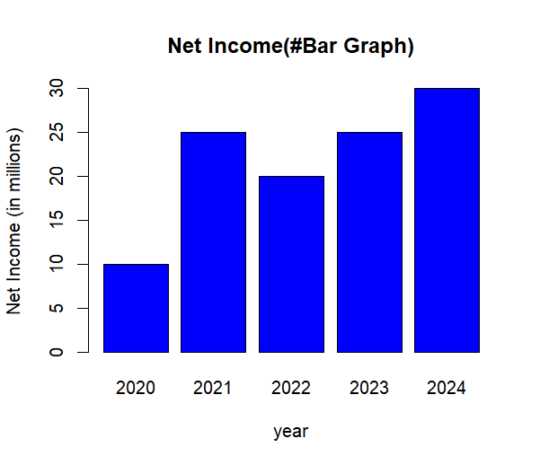

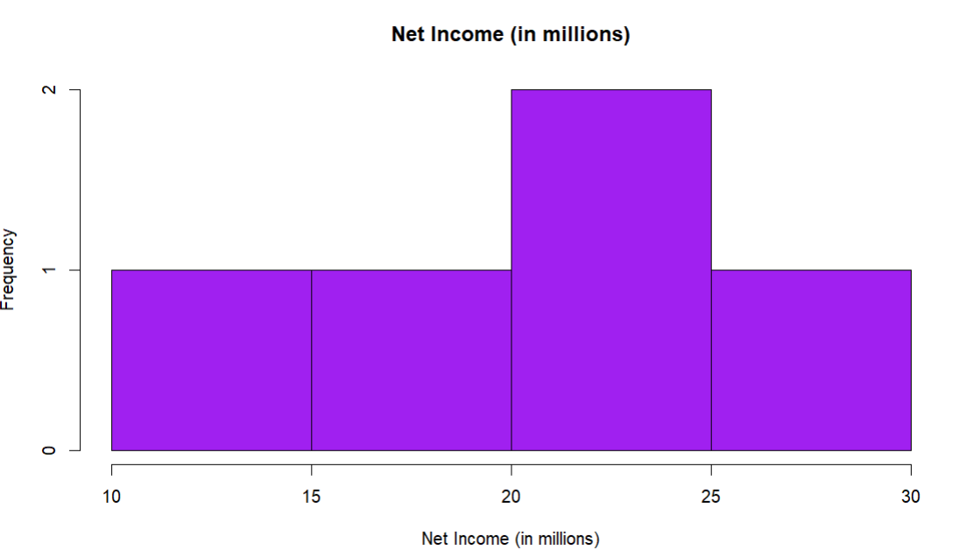

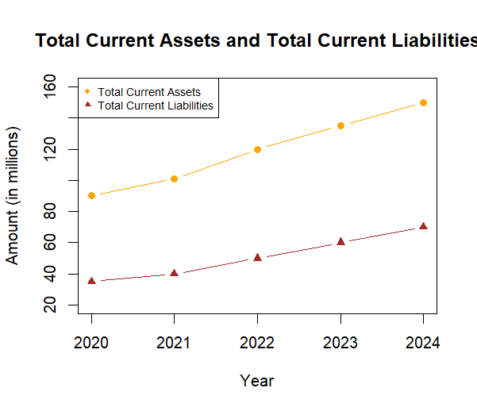

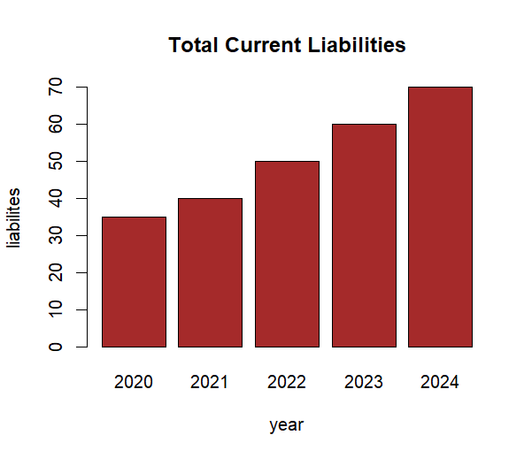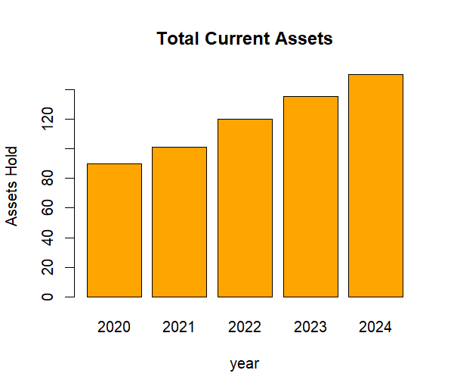

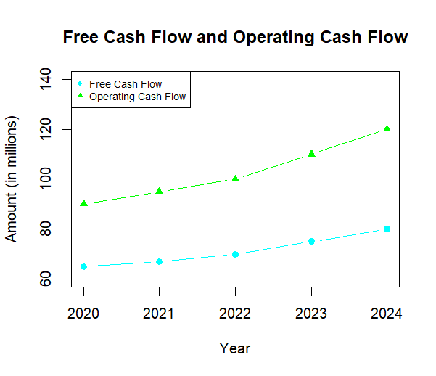

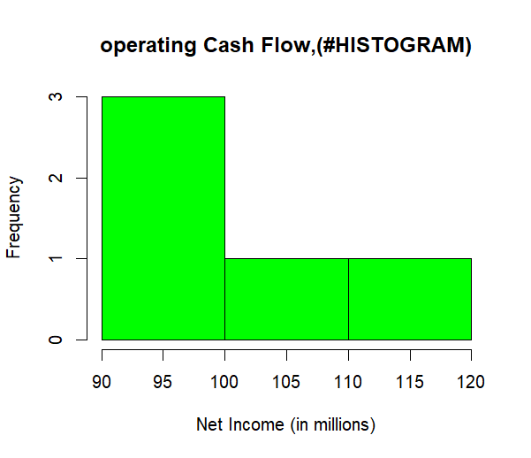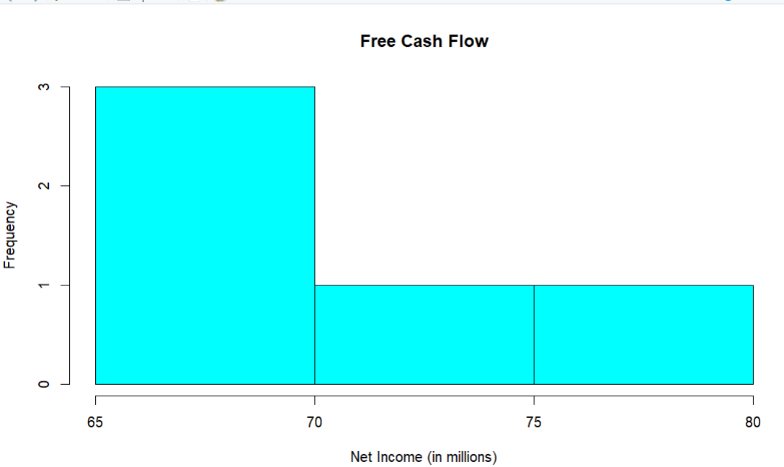

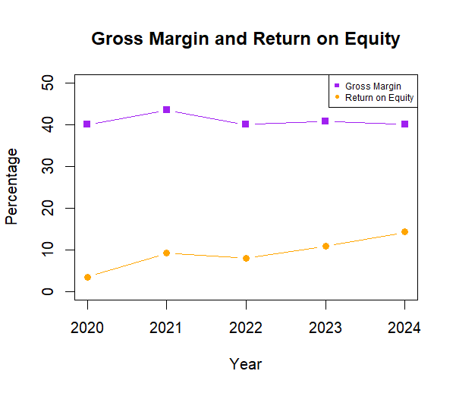

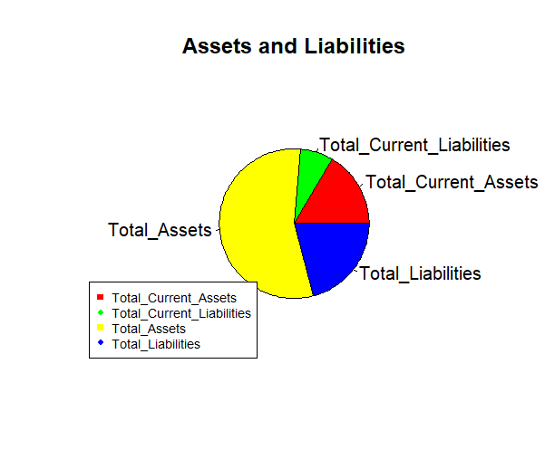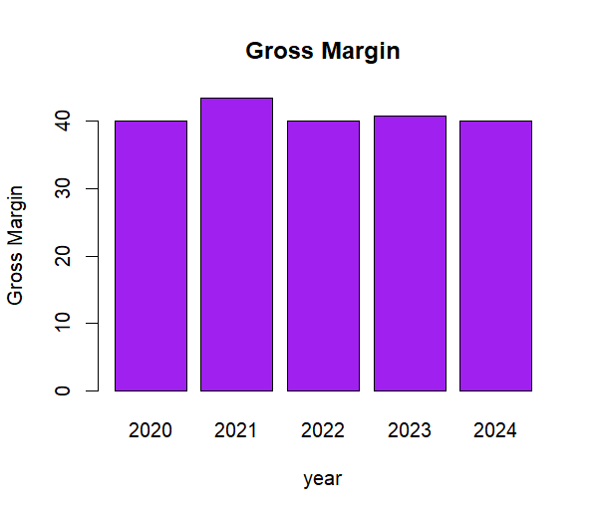

**Conclusion**

To conclude a company financial analysis project using R programming,Financial Performance: Provide an overview of the company's financial performance. Include key financial metrics like revenue, profit margins, and growth rates. Liquidity and Solvency: Assess the company's liquidity and solvency using ratios like the current ratio and debt-to-equity ratio. Discuss whether the company has the financial capacity to meet its short-term and long-term obligations. Profitability: Analyze the company's profitability using metrics such as net profit margin, return on equity (ROE), and return on assets (ROA). Discuss the company's ability to generate profits from its operations. Efficiency: Evaluate the efficiency of the company's operations by looking at metrics like asset turnover and inventory turnover. Discuss whether the company is using its assets effectively.Market Valuation: Consider the company's market valuation by examining metrics like price-to-earnings (P/E) ratio and price-to-book (P/B) ratio. Compare these ratios to industry averages if available.Cash Flow Analysis: Analyze the company's cash flow statement to assess its ability to generate cash from operating activities, invest in growth, and pay dividends or reduce debt. Risk Factors: Discuss any significant risk factors that could impact the company's financial stability and performance, such as industry trends, regulatory changes, or competitive pressures. Future Outlook: Provide insights into the company's future prospects based on the analysis. Discuss any opportunities or threats that the company may face and how it plans to address them.

Recommendations: Summarize your overall assessment of the company's financial health and whether it's a good investment or poses risks. Offer recommendations for investors or stakeholders based on your analysis. Limitations: Acknowledge any limitations of your analysis, such as data availability, assumptions made, or external factors that could influence the results. Appendix: Include any additional charts, graphs, or tables that support your analysis but were not included in the main body of the report.

**REFERENCES**

## Books

* + - "R for Data Science" by Hadley Wickham and Garrett Grolemund.
    - "Shiny in Action" by Hadley Wickham.

## Online Tutorials and Documentation:

* + - R Project's official website: https://[www.r-project.org/](http://www.r-project.org/)
    - Shiny documentation: https://shiny.rstudio.com/
    - RStudio's online learning resources: https://education.rstudio.com/learn/

## Blogs and Websites:

* + - R-bloggers: https://[www.r-bloggers.com/](http://www.r-bloggers.com/)
    - RStudio blog: https://blog.rstudio.com/
    - R Views: https://rviews.rstudio.com/

## Forums and Q&A:

* + - Stack Overflow's R tag: https://stackoverflow.com/questions/tagged/r
    - RStudio Community: https://community.rstudio.com/

## GitHub Repositories and Projects:

* + - Explore GitHub repositories related to Shiny applications and R data visualization.